**AWS WAF**

Create a VPC , two different subnets in different zone and create a route table and   
connect igw, and create a EC2 and install apache, make sure security group inbound   
rule allows traffic for port 80

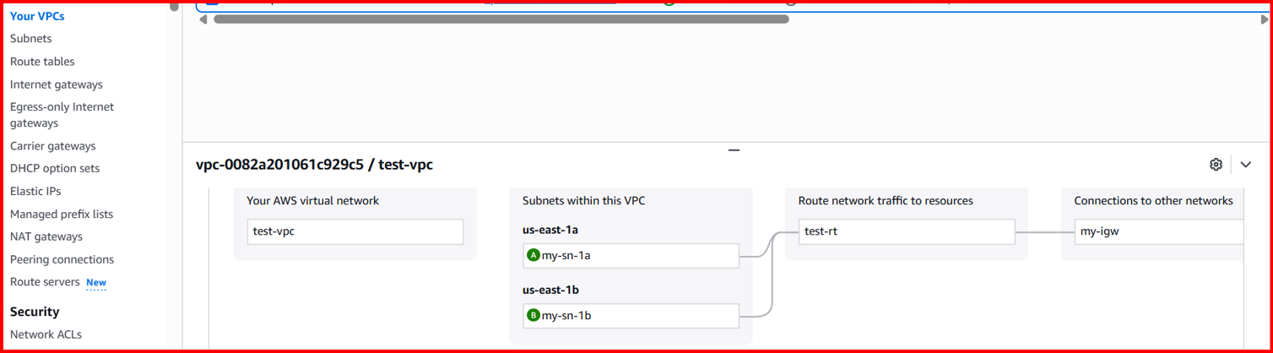

Created a target group by adding instance and create a application load balancer with   
listener http port and attached the group

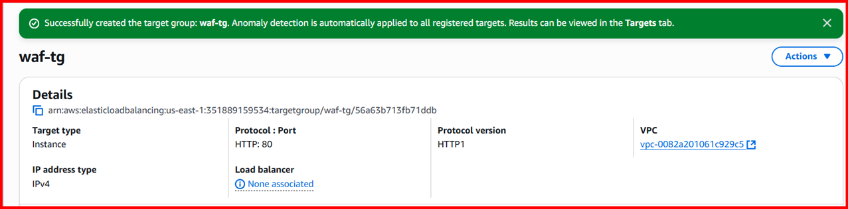

Go to AWS WAF → IP SETS added my laptop for block.

Now created web application firewall and add the rule with above ip set

1. Go to AWS WAF → IP SETS added my laptop for block.

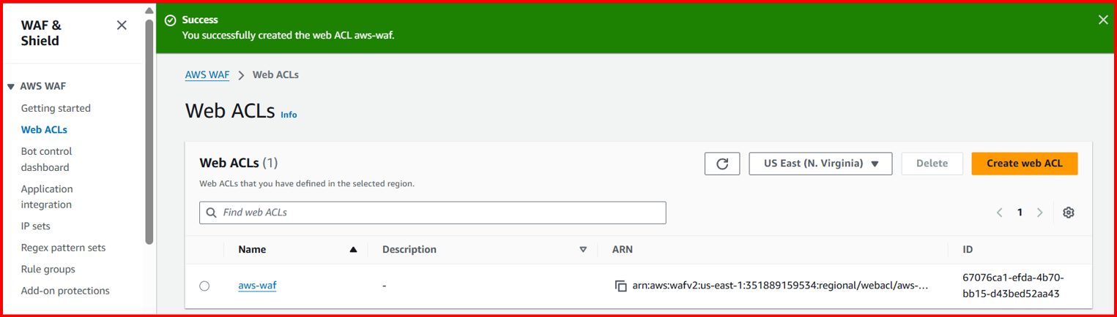

Now copy the dns name and check in url

You will blocked

